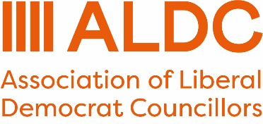
G8 Production Document
Key Facts
- The G8 award programme is for a posted piece of direct mail to key voters.
- The direct mail is a squeeze mailing which will go to the same group of people twice.
- You need use the templates available; they are designed to ensure the right information is in the right place, for example the address appears in the window.
- Your total award is split between two G8 mailings.
- You can use Artworker to produce the letter at aldc.org/artworker and select G8 templates.
- The templates and links are available on this link so you can also produce them in Affinity.
- All artwork MUST be uploaded via Artworker so the award code can be used. This can either be artwork made in Artworker, or PDFs that have been uploaded.

FAQs
What is included in my award?
The letter is single sided A4 with a double-sided A4 insert stuffed in a window envelope. It is two letters to the same people, one is sent at the start February, and one at the start of March.
I have a G8 Award but no code. Why?
You need to have a candidate in place in order to receive the award. If you didn’t have a candidate when you applied, there needs to be one in place by the artwork deadline below. As soon as there is a candidate, email abi.bell@aldc.org and your code will be released.
Why have I got a voucher code?
When you order your letters through Artworker, it will ask you to pay. Applying the voucher code is how you receive your award. You can only use the voucher once and you do not get credit if you do not use the full award.
The number of letters that you receive as part of your award was confirmed in the initial email you received. If your list is bigger than that, additional mailings can be ordered and will be charged at £1.06.
You will get a code for G8-2 after the deadline for G8-1 has passed.
What are the deadlines for G8 -1 and G8-2?
The deadlines are:
- G8:1 – 10am on Monday 19 January 2026
- G8:2 – 10am on Monday 9 February 2026
Artwork must be uploaded onto Artworker and the data must have been sent to Election Workshop by the deadline.
Where are the templates?
You can find all of the G8 templates at artworker.aldc.org and select G8 templates. A direct link to the templates is https://artworker.aldc.org/designs/?pid=3256
They will also be available shortly on the ALDC Website.
How do I log onto Artworker?
If you are a member of ALDC, log into the ALDC website first and then from the Menu select ‘Templates and Bulk Buys’ and then ‘Artworker’. This will mean you are already logged into the Artworker site.
If you are NOT a member of ALDC – visit artworker.aldc.org and select the alternative sign in options from the bottom of the page
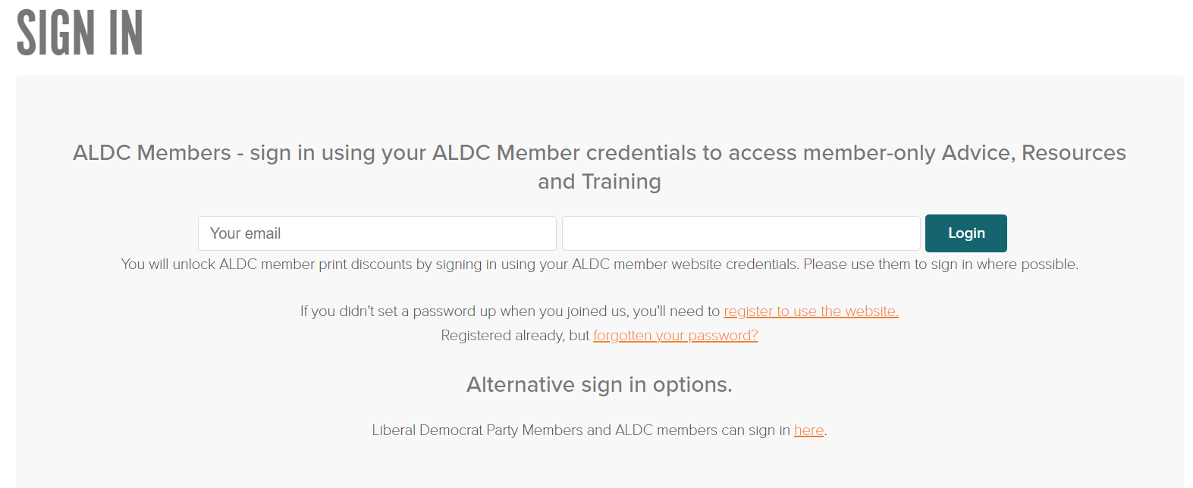

How do I get my data to Election Workshop?
You must get your data from Connect and download it into an Excel spreadsheet. The spreadsheet must then be encrypted with a password.
The spreadsheet is then emailed to Election Workshop enquiries@electionworkshop.co.uk and the password sent via text to 07535 626705. Both the email and the spreadsheet need to have your name, your ward and G8 in the title so we know which piece of artwork it links with.
You will NOT need to resend your data for G8:2 as we will assume that the G8:2 mailing is to the same people.
A more detailed description of how to present data is available in the ‘How to present your data guide’.
I want to send more letters than the award amount and/or to a ward that I haven’t received a grant for.
That’s brilliant! Direct mail is one of the best campaigning tools so doing more will help your campaign. When you do your order, you apply the voucher code when you pay.
This deducts the amount of the award from the cost.
If you want to do additional wards, you will have to pay £12 for the new version and then the £1.06 per letter. There is also the option for hand delivery for additional wards only. This is £12 plus 23p per letter. The letters for the G8 awards MUST be posted.
If you want to order extra letter in addition to your G8 award for hand delivery, there is a separate product to do so. This is clearly labelled in the Artworker shop. You can use the same artwork, just note the original Artworker order number in the order. Contact Election Workshop if you need help.
To upload artwork for additional wards use this link https://artworker.aldc.org/print/aldc-templates---upload-your-own-artwork/g8/
Do I have to use ALDC Artworker to complete the artwork?
No. You can create your own artwork, but it must be uploaded to Artworker to apply the voucher discount code. This is the link to upload your own artwork https://artworker.aldc.org/print/aldc-templates---upload-your-own-artwork/g8/
Can I get help with doing the artwork and getting the data?
Yes, you can. Election Workshop can artwork the letter and insert for you if you provide the content to them directly. Artwork support costs £45 +VAT and you should email content to enquiries@electionworkshop.co.uk
Please contact your local ALDC Development Officer, LDHQ Campaign Manager or Regional Development Officer if you need help with your data. They may also be able to help with your artwork.
If you indicated on your application that you needed support with artwork and / or data, this information has been shared with Election Workshop and your local ALDC Development Officer, LDHQ Campaign Manager and Regional Development Officer.
What happens if I miss the deadline?
If you miss the deadline for G8-1 the full award will be redistributed and you will not receive the award for G8-2. If you met the deadline for G8-1, but missed the deadline for G8-2, only the G8-2 award will be redistributed.
Key Contacts
- ALDC Office number: 0161 302 7532
- ALDC email: info@aldc.org
- Election Workshop number: 0161 272 6216
- Election Workshop email: enquiries@electionworkshop.co.uk

