How to prepare your data for G8
This short guide is to help you send your G8 data to Election Workshop in the correct format and in line with GDPR.
This guide only deals with how to format the information, not what the information should be or how to use Connect.
If you need help to create your list, or decide who the letters should go to, then please contact your ALDC or LDHQ field officer for advice and support.
- When you have built your list, run the list and click ‘Export’
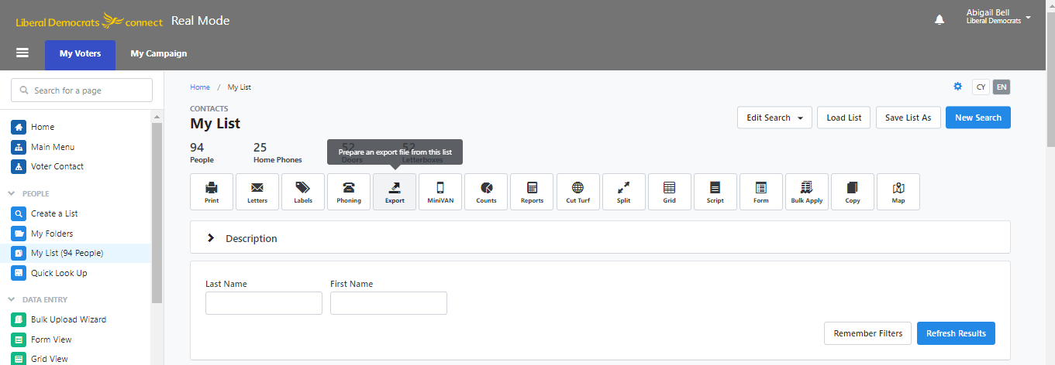
- This takes you to the Export Wizard. The first thing you need to do is to select the export format, which for this need to be the Household mailing list.

- Now click on ‘Export As’ and select Excel
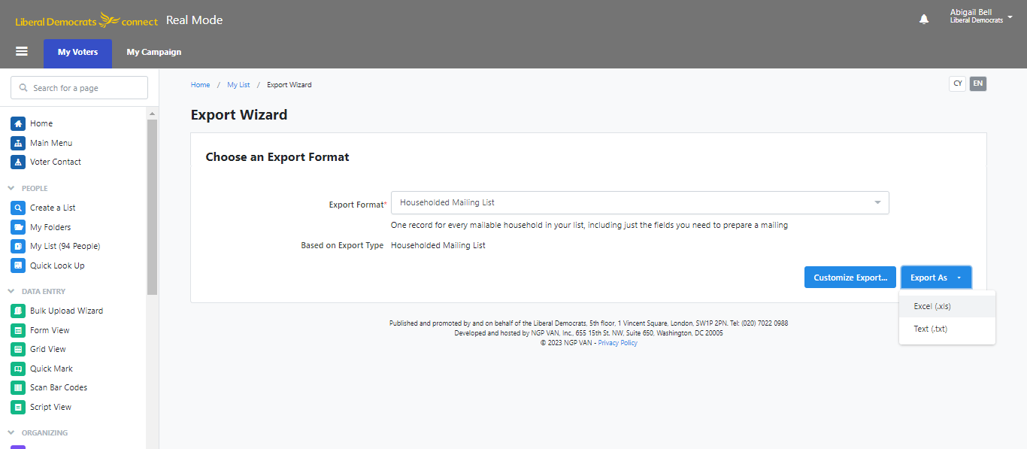

- Connect will now process your export and you can download it
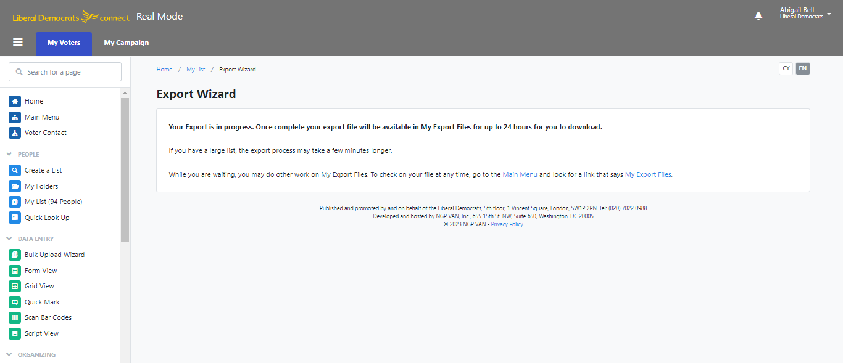
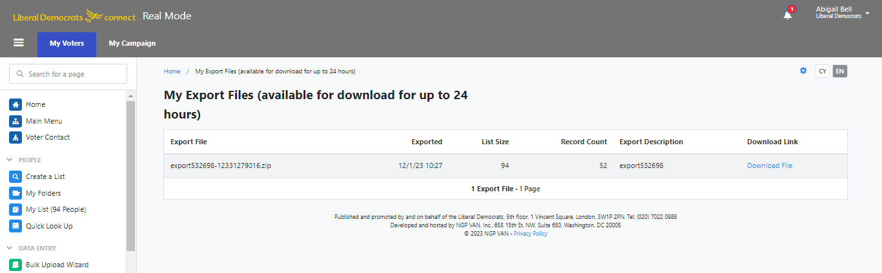

- Once your download has completed, open the document. There are a lot of columns – don’t worry about this!
It is VITAL that these column headings are NOT changed. These will be the merge field used to create your letters.
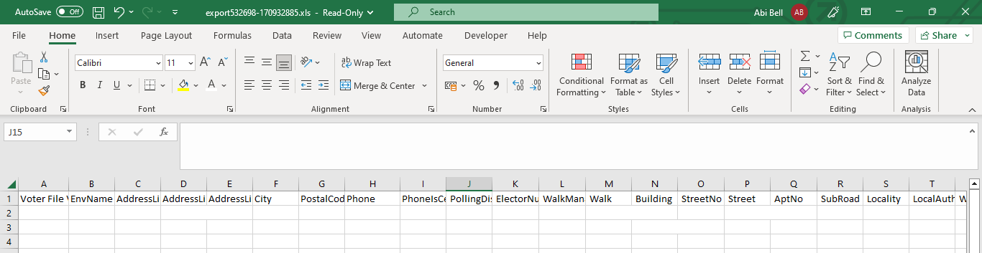

- You now need to save your spreadsheet and password it. Click ‘Save As’ and name your file using the Ward Name followed by the Council, i.e. Hill Ward Forest Council. Make sure the format is Excel Workbook. Make sure you save it where you can find it!
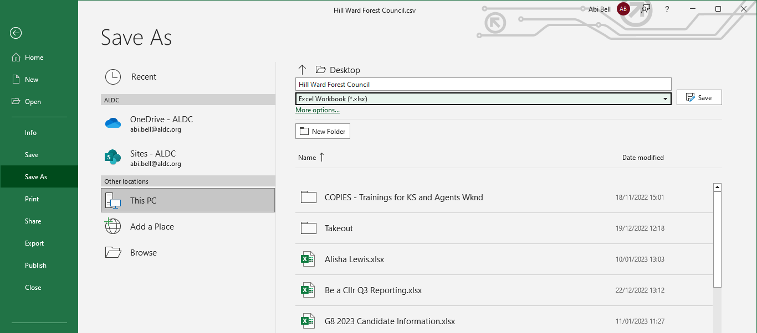

- To password your file, click ‘File’ and then select ‘Info’
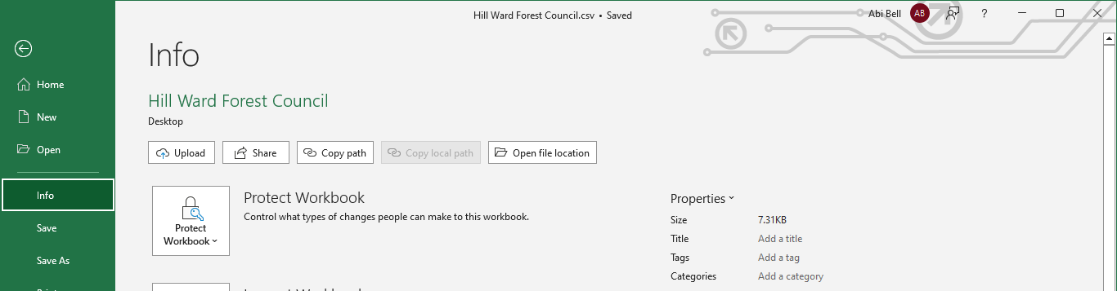

- From here, select ‘Protect Workbook’ and then ‘Encrypt with Password’
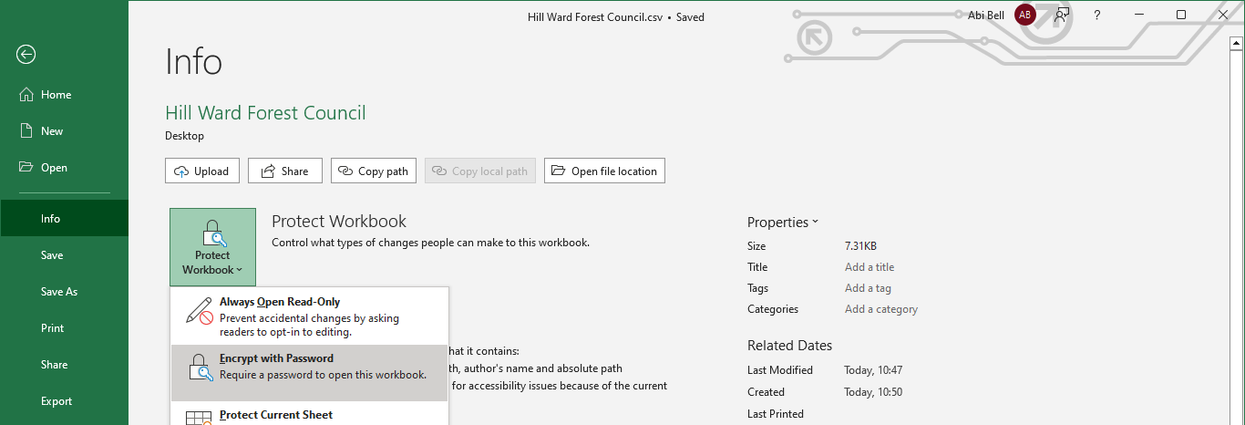

- You will then be asked to type in a password, twice. Make sure to keep a note of the password.
- Email the spreadsheet to enquiries@electionworkshop.co.uk with the subject heading of the email detailing G8, the ward and local authority

- Once you have sent Election Workshop your data, you will need to send the password. This is a specific phone number (which is not any of the staff phone numbers) for you to text. This means that only the staff member dealing with your data knows the password.

TEXT
07535 626705

Your text should include your name, your ward/constituency, your mailing project (e.g. G8) and your password.

Please do not send passwords by email or WhatsApp, and please be sure to send the password to the right phone number.

