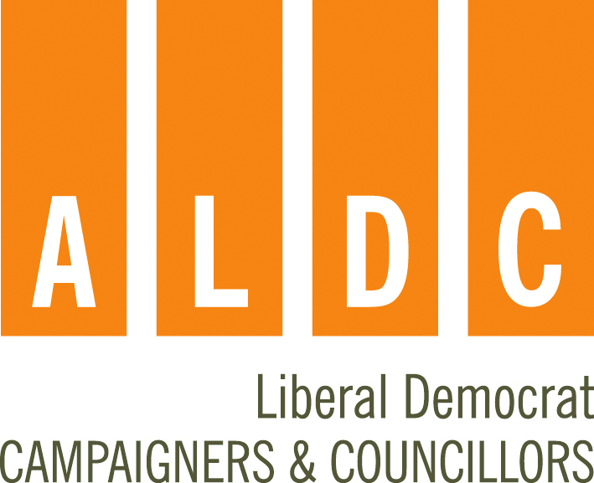
Application Pack
aldc.org
aldc.org
aldc.org
North East Region Development Officer

Thank you for your interest in the post of North East Region Officer

This is a new post, funded by the North east Region Liberal Democrats, and managed on behalf of North east Region by the Association of Liberal Democrat Councillors (ALDC).

You will be responsible for establishing and boosting Liberal Democrat activity across the North East, particularly in those local parties who have, as yet, few or no elected Councillors. You will provide first class support to local party activists and potential new activists and develop their campaigning plans, skills and capacity.

The post is full time and will work closely with the North East Region Officer team and ALDC to agree priorities for the growth and advancement of Liberal Democrat campaign activity across the Region.

The job will be home based and a significant amount of travel around the North East will be required, including evening and weekend events. From time to time attendance at events outside the North East, including ALDC events, will be required.

A Job Description and a Person Specification are included in this pack.

The post will be paid at ALDC Officer level, based on the NJC scale spinal points 23-28 (on the scale that comes into force on 1st April 2019). We also contribute an additional 8% of your pay to your pension scheme (after 3 months in employment).

How to Apply

Applications should be in writing to the North East Region Vice Chair (Campaigns), Niall Hodson. Please send this by email to niallhodson@gmail.com .

Please write explaining why you wish to be considered for the post and address key points from both the person specification and job description. Please also enclose a short Curriculum Vitae which should include at least two referees – one of whom should be your current or most recent employer. We may contact your referees before your interview unless you tell us otherwise. Please also complete the monitoring form.

The deadline for applications is Noon on Monday November 11th 2019

Applicants shortlisted for interview will be expected to make themselves available to attend an interview in Durham on November 18th (subject to General Election exigencies.

Further Information

Further information about the role can be obtained from the North East Region Vice Chair (Campaigns), Niall Hodson either by email to niallhodson@gmail.com or by phone on 07720842833.

Job Description, Regional Development Officer

Post | Regional Development Officer
Grade | £23,836 (full time salary)  NJC SCP 17-21 (2019 – 20)
Mileage allowance | Work related mileage allowance to be paid at 25p per mile to a maximum of 12,000 miles per year.
Reports to: | Regional Officer Team
Line management responsibility for: | ALDC
Payroll | Managed through ALDC
Location | Home based
Hours | The role covering 40 hours a week across the North East, including a significant amount of evening and weekend work, such as attendance at Party and ALDC conferences

Purpose

To support and develop Liberal Democrat activists at a local level, to enable them to campaign and win elections.

Main Responsibilities

- To provide guidance, support and training to Liberal Democrat activists in the North East Region which will help develop teams to have the capacity for longer term campaigning and electoral success.

- To help Liberal Democrat activists develop the skills and motivation to campaign effectively, through attendance at regional and local events, training and meetings.

- To work with local parties, council groups and members to develop and review Development Plans within every local authority of our Region to develop the campaigning and capacity of these local parties/council groups.

- In relation to the above, to pay particular attention to principal local authority areas where there is currently no elected representation.

- To provide and organise additional training and support at a local, county or regional level either through training sessions, or twinning with other seats and practical training through involvement in local by-elections and other elections.

- To assist local parties and council groups with digital campaigning and social media.

- To work with the Regional Executive to revive branches which have become defunct in any local authority area.

- To support principal authority by-election teams across the region, with particular priority to a) by-elections where Liberal Democrats are defending seats, b) by elections where there is evidence to support a reasonable expectation of winning, and c) by elections in principal authorities on which have no elected representation.

Shared Responsibilities (with the rest of the political team)

- To deliver training and learning opportunities to Liberal Democrat councillors and campaigners, including the research and development of training materials.

- To ensure the delivery of an agreed programme of events throughout the year.

- To represent the Region as agreed by the Regional Chair.

General

- To work within the organisation’s agreed policies and procedures.

- To attend regional meetings and conferences as required.

- To take advantage of staff development opportunities and periodic performance reviews in accordance with terms and conditions specified by the Region.

- To assist in the day-to-day administrative duties as appropriate and to produce written reports as requested.

- To undertake other reasonable duties at the request of the line manager

Person Specification, Development Officer

Essential

- In evident sympathy with the aims and objectives of the Liberal Democrat Party.

- To be a self-starter and be able to work without day to day management and with many different groups of people.

- Knowledge and understanding of Liberal Democrat local campaigning
demonstrated by significant involvement in campaigning at a local level.

- Ability to work with Liberal Democrat activists, including speaking in public, providing training and motivating teams.

- Good communication skills, both written and verbal, and the ability to work as part of a team and to organise your own work, and able to work weekends and evenings.

- Good IT skills, including ability to work DTP packages. Ability to explain Lib Dem IT and other computer programmes and databases to Lib Dem members.

- Good interpersonal skills and an ability to listen and work with and support development through positive encouragement and reflection. Ability to work with diverse groups and occasionally challenging individuals.

- Good understanding and experience of using social media with the ability to show how Facebook, Twitter and other social media platforms can support campaigning.

- Good understanding and experience of using databases and merging functions such as Connect, Nationbuilder, Word and MailChimp and to be able to show how these can enable political campaigning.

Desirable

- Member of the Liberal Democrats and ALDC

- To hold a full driving licence, or show how working across the Region could be accessed by provision of other transport without loss of time to the employer.

- Accredited Party Trainer.

